Lockedme.com

Application Screenshots

Version History

|  |  |
| --- | --- |
| Author | Vivek Ranjan |
| Purpose | Screenshots of the application |
| Date | 15/08/2021 |
| Version | 1.0 |

Table of Contents

Main menu screenshot 2

1. Display all Files 2

2. Add new file 3

3. Delete a file 3

a. Delete a file (Exception Handling) 4

4. Search file 4

5. Exception Handling wrong choice 4

6. Exit 5

GitHub Screen shot 6

1. Initial Commit 6

2. First commit and push to GitHub 7

3. Final Commit and Push to GitHub 7

# Main menu screenshot

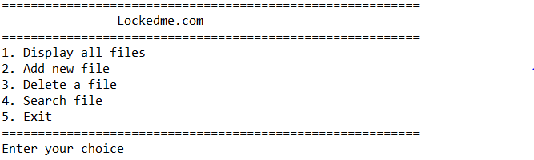

## Display all Files

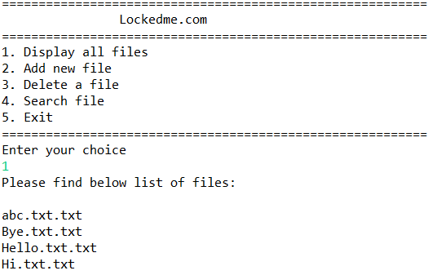

## Add new file

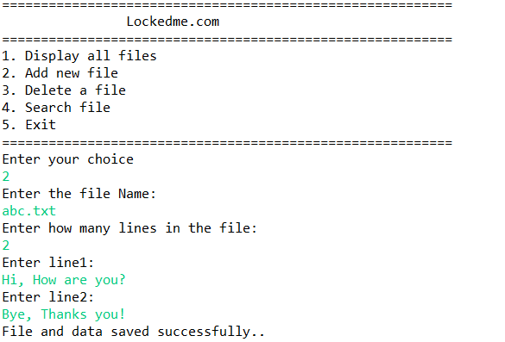

## Delete a file

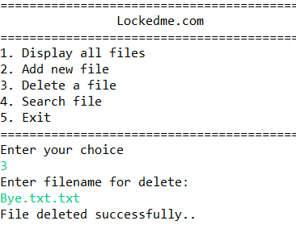

### Delete a file (Exception Handling)

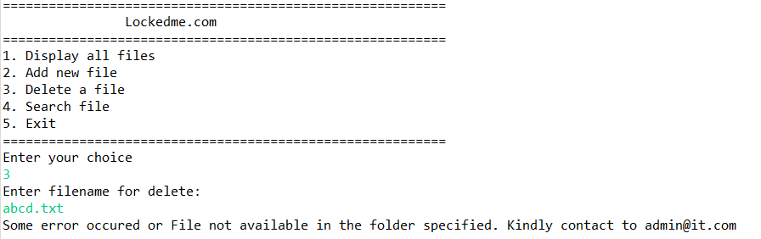

## Search file

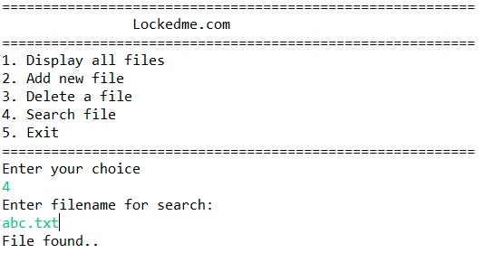

## Exception Handling wrong choice

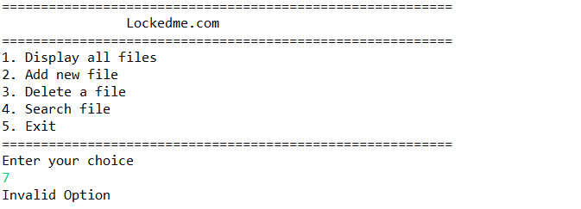

## Exit

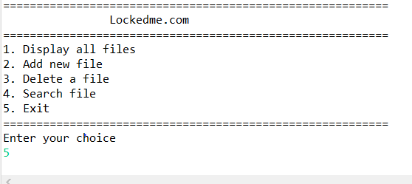

# GitHub Screen shot

## Initial Commit

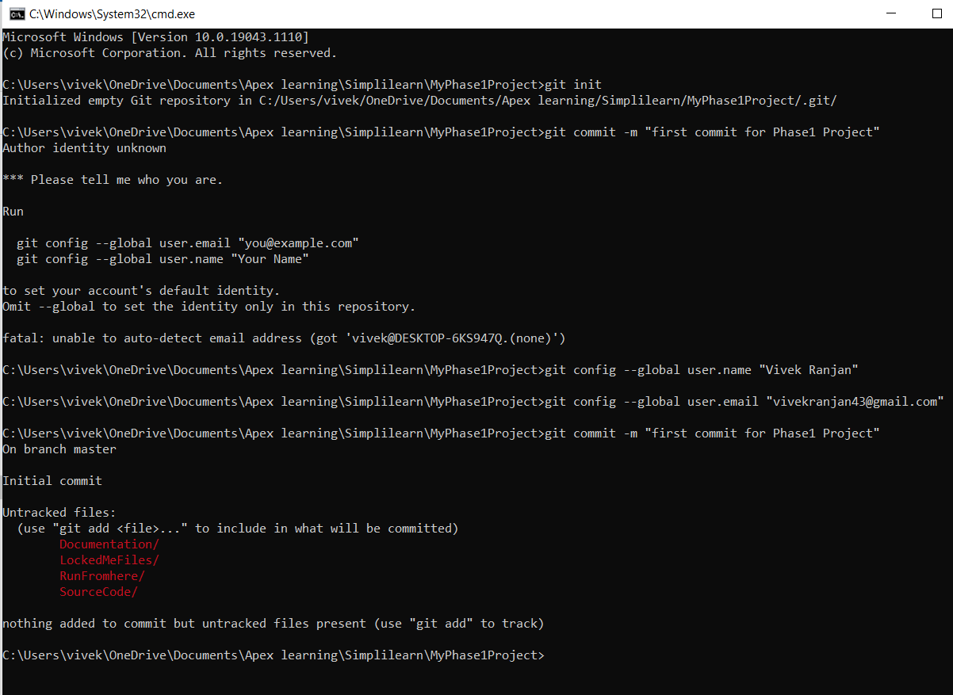

## First commit and push to GitHub

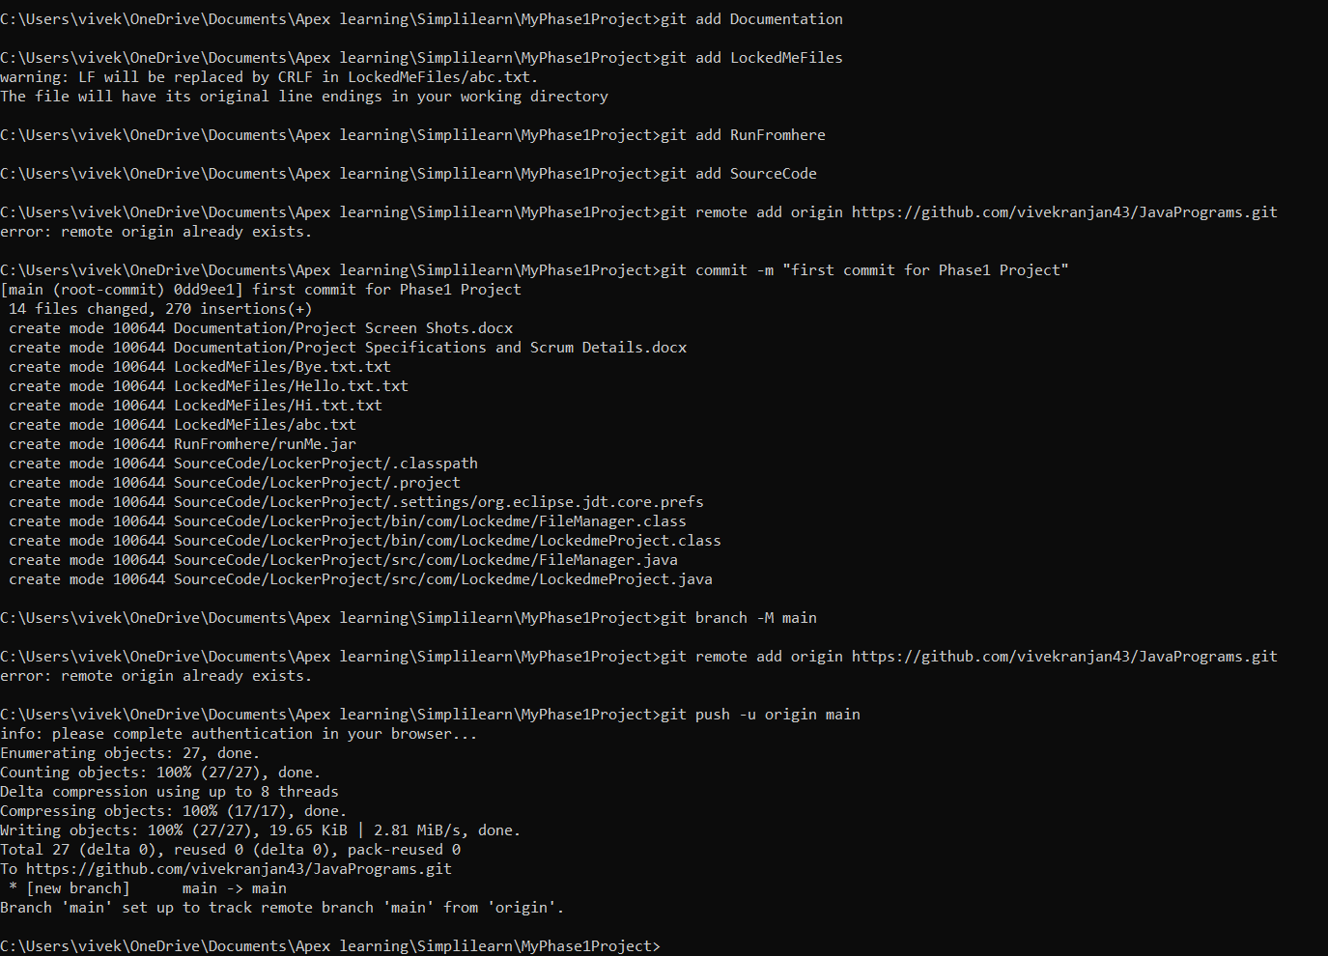

## Final Commit and Push to GitHub

